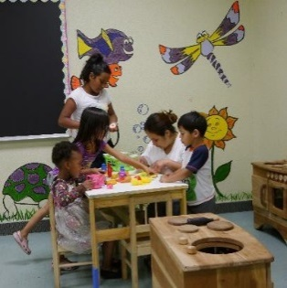
About Our Services
Hours: Tuesday - Saturday, 9:30 AM - 3:00 PM

Community Center
Enjoy free coffee, pastries, and a warm environment in our Community Center. The Help
Desk assists with referrals for your needs, and a computer and phone are available.

Community Center Clothing Closet
Adult men and women in need may access gently-worn donated clothing free of charge.

Men’s Center
Showers and laundry facilities are available daily.

Women’s Center
Showers, laundry facilities, and female focused-referral services are available.

Women’s Center Baby Room
Parents may receive complimentary supplies for babies and children, subject to availability. Children may enjoy a fun playroom in the Women’s Center.
Free Dining Room
Lunch is served every Tuesday-Saturday from 10:45 am-12:45 pm.
Winter Shelter
The SVdP Winter Shelter is open to individuals with vouchers between
November and April. Drop-ins may also be accommodated if there are available beds.

Special Programs

Note: Below is a sample of special programs that take place at the Community Center, subject to change. Please see monthly calendar for up-to-date listings.

Health Care
Health screenings are offered Wednesdays in the Dining Room, and a mobile clinic is parked outside on Fridays, and a free podiatry clinic takes place every third Wednesday of the month.

Family Celebrations
Come celebrate Christmas, Easter, and Back to School. Pre-registration is required.

Workforce Training
Professional development programs are available to those wishing to develop skills in the culinary arts.

Hair Cuts
Offered every Tuesday and Friday in the Community Center from 11 am – 2 pm.

Volunteer-Led Activities
Yoga, acupuncture, art stations, and computer skills workshops are a few ways in which volunteers bring their talents to SVdP.

● St. Vincent de Paul Community Center ●
● 2272 San Pablo Avenue, Oakland CA 94612 ●
● 510-638-7600 ●

