

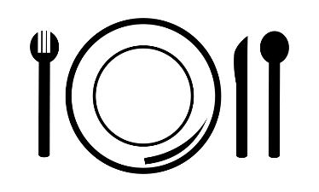

**Food – Don’t Waste It!**

Food – D

That’s more than 20 pounds per person, per month, and $165 billion worth of food each year.

40% of all food produced in the U.S. is wasted. U.S. families throw out 25% of the food and beverages they buy.

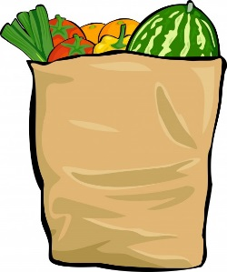

This food is then used to provide **free hot lunch 5 days a week** to those in need, and to distribute food boxes to local households.

**SVdP receives and reutilizes about 68,000 pounds of food per month** from grocery stores, food producers, suppliers, bakeries, and restaurants that otherwise would have gone to waste.

To learn more about how you can support SVdP’s programs through volunteering, contact the

Volunteer Team at [volunteer@svdp-alameda.org](mailto:volunteer@svdp-alameda.org) or (510) 877-9252.

Meanwhile, 1 in 6 Americans

lack a secure supply of food to

their tables. Reducing food losses

by just 15% could feed more than

25 million Americans every year.

How does SVdP help?